
SIMATS ENGINEERING
ASSESSMENT TOOL 2
CONSTRAINT-BASED
PROBLEM SOLVING

NAME: | Geetika T
REG NO: | 192511469
COURSE: | Artificial intelligence
COURSE CODE: | CSA1701

1. Hospital doctor-to-shift assignment
The hospital has three doctors and three shifts. Each doctor must receive exactly one shift, each shift must be used once, D1 cannot work at night, D3 cannot work in the morning, and D2 must work earlier than D3.

1.1 Formal model
- Variables: D1, D2, D3; each domain is {Morning, Afternoon, Night}.
- All-different: no two doctors may receive the same shift; each doctor receives one shift.
- Unary constraints: D1 ≠ Night; D3 ≠ Morning.
- Ordering constraint: rank(D2) < rank(D3), where Morning = 1, Afternoon = 2, Night = 3.
- Goal test: all three doctors are assigned and every constraint is true.
The all-different condition plus three variables and three shifts means a complete legal assignment is a permutation of M, A, and N. A partial assignment is rejected as soon as it violates a constraint; there is no reason to continue exploring that branch.

1.2 Backtracking search trace
To show the search clearly, I assign doctors in the order D1 → D2 → D3 and try shifts in the order M → A → N. Whenever a choice breaks a rule, I undo it and try the next shift.
Step | Partial assignment / trial | Constraint check | Decision
1 | D1 = M | D1 is not assigned N. No duplicate exists. | Keep M.
2 | Try D2 = M | M is already used by D1; violates one-doctor-per-shift. | Reject; backtrack D2.
3 | Try D2 = A | A is unused. Ordering is not yet fully testable because D3 is unassigned. | Keep A.
4 | Try D3 = M | D3 is forbidden from Morning; also M belongs to D1. | Reject; backtrack D3.
5 | Try D3 = A | A is already assigned to D2. | Reject; backtrack D3.
6 | Try D3 = N | N is unused; D3 is not in Morning; rank(D2)=2 < rank(D3)=3. | Accept complete solution.

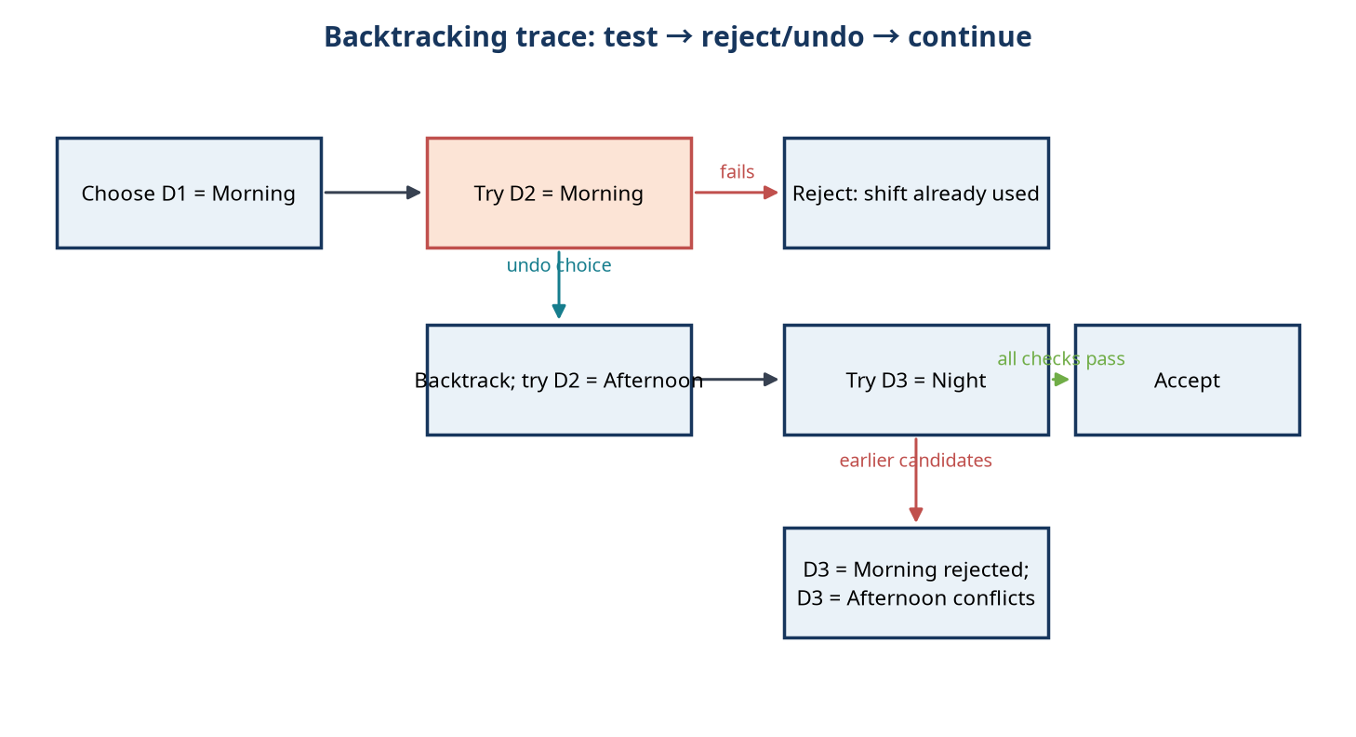
Figure 1. One depth-first branch, with rejected choices visibly undone.

1.3 Final schedule and verification
Shift | Doctor
Morning | D1
Afternoon | D2
Night | D3

This schedule uses each shift once. D1 is not on Night, D3 is not on Morning, and D2’s Afternoon shift comes before D3’s Night shift.

Why backtracking fits
This is a small constraint-satisfaction problem: assignments are built incrementally, and illegal partial assignments can be pruned immediately. Backtracking is complete for this finite search space when it explores every remaining value; in the worst case it may examine up to 3! = 6 complete permutations here, but early constraint checks reduce the actual work.

1.4 Python implementation
SHIFTS = ("Morning", "Afternoon", "Night")

def valid_partial(a):
# No shift can be used twice.
if len(set(a.values())) != len(a):
return False
if a.get("D1") == "Night":
return False
if a.get("D3") == "Morning":
return False
# Check the ordering as soon as both doctors are assigned.
if "D2" in a and "D3" in a:
if SHIFTS.index(a["D2"]) >= SHIFTS.index(a["D3"]):
return False
return True

def backtrack(order, i=0, assignment=None):
if assignment is None:
assignment = {}
if i == len(order):
return assignment.copy()
doctor = order[i]
for shift in SHIFTS:
assignment[doctor] = shift
if valid_partial(assignment):
answer = backtrack(order, i + 1, assignment)
if answer is not None:
return answer
del assignment[doctor] # undo the trial before trying another value
return None

answer = backtrack(["D1", "D2", "D3"])
print(answer)
# One valid output: {'D1': 'Morning', 'D2': 'Afternoon', 'D3': 'Night'}
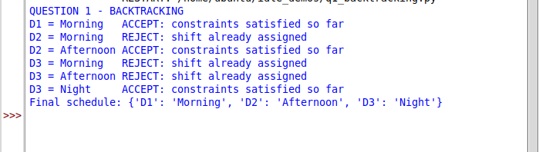
Figure 2. Direct Python IDLE 3.12.3 Shell capture after running q1_backtracking.py

2. Grid navigation with BFS
Breadth-First Search (BFS) explores a graph one depth level at a time. Because each legal move in Question 2 costs exactly 1, the first shortest route BFS finds is also a minimum-cost route. The prompt does not specify a concrete map, so the following grid is an explicit example rather than information supplied by the question.
Worked map assumptions: a 5 × 5 grid; S = (1,1); G = (5,5); blocked cells = (2,2), (2,4), (3,2), (4,4); four legal moves (Up, Down, Left, Right), each costing 1. For a reproducible trace, neighbors are considered Right, Down, Left, Up.
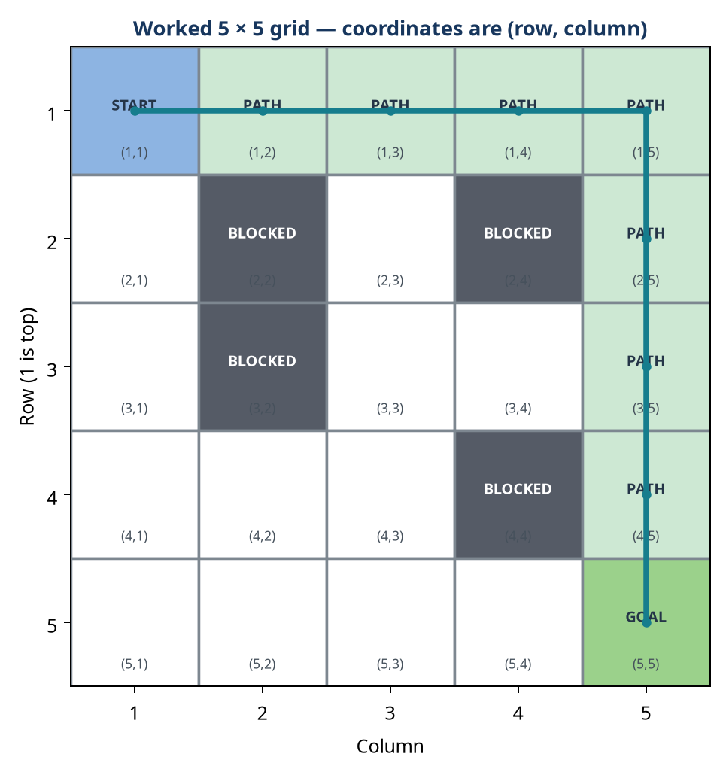
Figure 3. BFS sample map. Green cells mark one shortest route; dark cells are obstacles.

2.1 State representation and Manhattan distance
A state is the robot’s current cell (r,c). A move creates an edge to an adjacent in-bounds cell unless that cell is blocked. The Manhattan heuristic is
h(r,c) = |r − 5| + |c − 5|. It ignores obstacles and counts the minimum number of horizontal and vertical steps in an empty grid.
At the start, h(1,1) = |1−5| + |1−5| = 8. Since each move costs 1, this is a lower bound on the path cost. The sample map contains a route of exactly 8 moves, so no route can be shorter.

2.2 BFS queue rule
BFS removes the oldest node from a FIFO queue, then appends each newly discovered neighbor to the rear. A visited/parent dictionary prevents repeatedly enqueueing a cell. In this problem the data structure is a queue—not a priority queue. The h values below are included to honor the heuristic part of the prompt and to show the lower bound at each expanded cell; they do not reorder BFS.
Step | Expanded node (g, h) | New nodes appended at rear | Queue size after update
1 | 11 (0,8) | 12, 21 | 2
2 | 12 (1,7) | 13 | 2
3 | 21 (1,7) | 31 | 2
4 | 13 (2,6) | 14, 23 | 3
5 | 31 (2,6) | 41 | 3
6 | 14 (3,5) | 15 | 3
7 | 23 (3,5) | 33 | 3
8 | 41 (3,5) | 42, 51 | 4
9 | 15 (4,4) | 25 | 4
10 | 33 (4,4) | 34, 43 | 5
11 | 42 (4,4) | 52 | 5
12 | 51 (4,4) | — | 4
13 | 25 (5,3) | 35 | 4
14 | 34 (5,3) | — | 3
15 | 43 (5,3) | 53 | 3
16 | 52 (5,3) | — | 2
17 | 35 (6,2) | 45 | 2
18 | 53 (6,2) | 54 | 2
19 | 45 (7,1) | 55 | 2
20 | 54 (7,1) | — | 1
21 | 55 (8,0) | — | 0

Notation in the trace: cell 12 means row 1, column 2. “g” is the number of moves from S. The frontier update at each step is: remove the expanded node from the front, then append the listed new nodes in the stated R, D, L, U order. When the goal is removed from the queue at Step 21, BFS stops.
For example, the initial queue is [11]. After expanding 11 it is [12, 21]; after expanding 12 it is [21, 13]. Each expansion removes the front item and appends new neighbors at the rear.

2.3 Reconstructing the path and calculating cost
Each newly discovered node stores its parent. Starting at G, follow parent links backward to S, then reverse the list. For the selected route:
(1,1) → (1,2) → (1,3) → (1,4) → (1,5)
→ (2,5) → (3,5) → (4,5) → (5,5)
Move count = 8 edges
Path cost = 8 moves × 1 cost per move = 8
Verification: no route cell is blocked; each consecutive pair is one legal orthogonal move; the route ends at (5,5). Since h(S)=8 and the found route costs 8, no shorter route can exist.
One shortest route is S → (1,2) → (1,3) → (1,4) → (1,5) → (2,5) → (3,5) → (4,5) → G. It has 8 moves and costs 8.

2.4 Heuristic priority queues: the A* distinction
The wording “BFS” and “priority queue using Manhattan distance” combines BFS with A*. These are not interchangeable. If the instructor specifically expects a priority queue ordered by the heuristic, the technically correct method is A*: each frontier entry is prioritized by f(n) = g(n) + h(n). Because all edge costs are 1 and Manhattan distance is admissible and consistent on a four-directional grid, A* returns an optimal path.
BFS uses a FIFO queue and guarantees the fewest steps when all moves have equal cost; it does not use h to order nodes. A* uses a priority queue ordered by f = g + h. On this four-directional unit-cost grid, Manhattan distance is admissible and consistent, so A* also returns an optimal path.
For this particular map, early A* queue updates have f = 8 on the optimal corridor. Ties are broken by insertion order (the same R, D, L, U neighbor order), so its early choices follow the same visible corridor as BFS. A different map can produce a different expansion order.
A* expansion | Removed node (g,h,f) | Priority entries inserted (g,h,f)
1 | (1,1) (0,8,8) | (1,2) (1,7,8); (2,1) (1,7,8)
2 | (1,2) (1,7,8) | (1,3) (2,6,8)
3 | (2,1) (1,7,8) | (3,1) (2,6,8)
4 | (1,3) (2,6,8) | (1,4) (3,5,8); (2,3) (3,5,8)
5 | (3,1) (2,6,8) | (4,1) (3,5,8)
6 | (1,4) (3,5,8) | (1,5) (4,4,8)

For this question, the BFS trace uses a FIFO queue. Manhattan distance does not change the BFS order; if a priority queue is required, that part should be described as A* instead.

2.5 Python BFS implementation
from collections import deque

N = 5
START, GOAL = (1, 1), (5, 5)
BLOCKED = {(2, 2), (2, 4), (3, 2), (4, 4)}
# Deterministic tie-breaking: Right, Down, Left, Up.
MOVES = [(0, 1), (1, 0), (0, -1), (-1, 0)]

def bfs(start, goal):
frontier = deque([start])
parent = {start: None}
while frontier:
current = frontier.popleft()
if current == goal:
break
for dr, dc in MOVES:
nxt = (current[0] + dr, current[1] + dc)
inside = 1 <= nxt[0] <= N and 1 <= nxt[1] <= N
if inside and nxt not in BLOCKED and nxt not in parent:
parent[nxt] = current
frontier.append(nxt)
if goal not in parent:
return None
path, node = [], goal
while node is not None:
path.append(node)
node = parent[node]
path.reverse()
return path

path = bfs(START, GOAL)
print(path)
print("cost:", len(path) - 1) # every step costs one

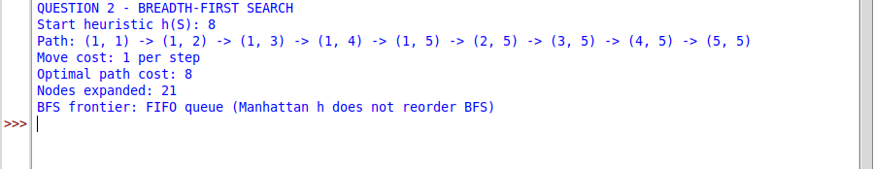
Figure 4. Direct Python IDLE 3.12.3 Shell capture after running q2_bfs.py.

3. Partially observable rescue robot
A rescue robot cannot assume it knows the whole building. It senses only adjacent cells, so its internal map is incomplete and can change as it explores. It must not only find a route: it must reason about movement cost, hazards, safety, and new information.

3.1 Constraint analysis and effect on decisions
Given condition | Effect on the agent’s decisions
Four-direction movement | The action set is {Up, Down, Left, Right}; diagonal shortcuts are illegal.
Blocked cells | An obstacle is a hard constraint: the robot must not enter it, even if that would be the shortest route.
Adjacent-cell sensing only | The world is partially observable. The robot maintains a belief/known map and cannot plan with certainty ove`r unseen cells.
Base cost 1 per move | Every move increases accumulated path cost g by 1.
Risk surcharge +2 | Entering a risky cell costs 1+2=3. Search must compare cumulative cost, not merely number of steps.
Dynamic knowledge / online search | After sensing or discovering a blockage, update the map and re-plan; a route that was previously preferred may no longer be feasible.
Safety requirement | When information is insufficient, do not blindly commit to an unobserved or known-dangerous cell. Use a safety rule and a conservative unknown-cell policy.

The key distinction is between “shortest path” and “least-cost path.” With nonuniform step costs, BFS is not generally cost-optimal. Uniform Cost Search (UCS) expands the currently lowest accumulated-cost state and is therefore the natural offline planner when all step costs are nonnegative.

3.2 Sample map and cost comparison
For a concrete demonstration, use the assumptions listed earlier: blocked cells (2,2), (3,2), (4,4); risk cells (1,2), (1,3); and cost 3 to enter a risk cell versus 1 to enter any other free cell.
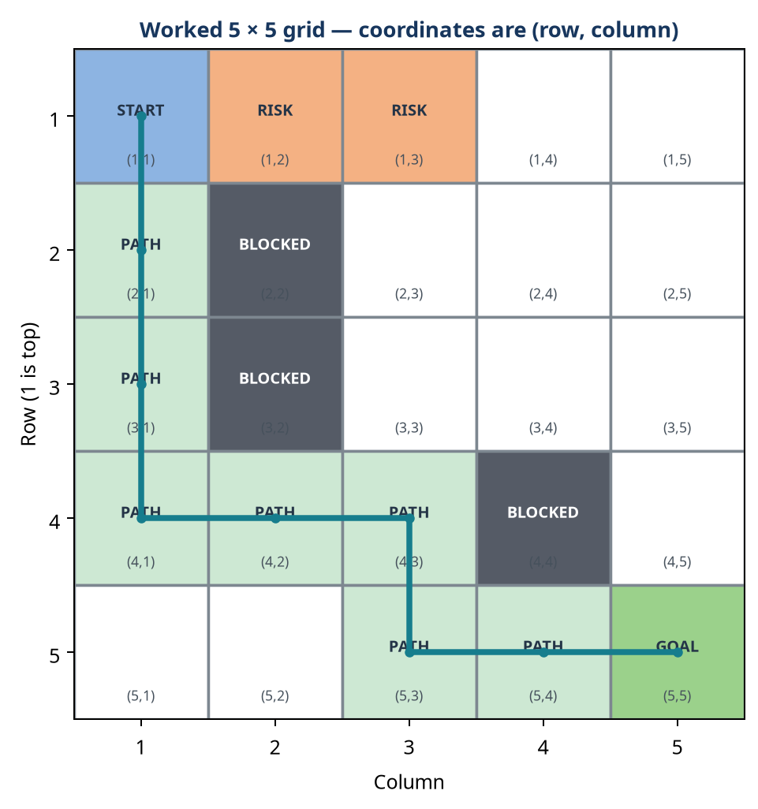
Figure 5. The teal route is the safe minimum-cost route. Orange cells are risky; dark cells are blocked.
Candidate route | Ordinary moves | Risk entries | Total cost
Top corridor: (1,1)→(1,2)→(1,3)→(1,4)→(1,5)→(2,5)→…→(5,5) | 8 | 2 | 8×1 + 2×2 = 12
UCS route: (1,1)→(2,1)→(3,1)→(4,1)→(4,2)→(4,3)→(5,3)→(5,4)→(5,5) | 8 | 0 | 8×1 + 0×2 = 8

The extra-risk charge is added on top of the ordinary move cost. Thus “risk = +2” means a risky entry costs 3 total, not 2. The bottom route has the same number of moves as the illustrated top corridor but avoids the two risk cells, so it is cheaper by 4.

3.3 Uniform Cost Search calculation
Let g(n) be the cheapest known cost from the current planning start to node n. When UCS considers a neighbor v, it computes g(v) = g(u) + 1 + 2·I(v is risky), where I is 1 for a risky cell and 0 otherwise. The frontier is a min-priority queue ordered by g; if a cheaper route to a known cell is discovered, its best cost and parent are updated.
Expansion order | Removed cell and g | New/updated frontier cells (cell: g)
1 | 11 : 0 | 12:3, 21:1
2 | 21 : 1 | 31:2
3 | 31 : 2 | 41:3
4 | 12 : 3 | 13:6
5 | 41 : 3 | 42:4, 51:4
6 | 42 : 4 | 43:5, 52:5
7 | 51 : 4 | —
8 | 43 : 5 | 53:6, 33:6
9 | 52 : 5 | —
10 | 13 : 6 | 14:7, 23:7
11 | 33 : 6 | 34:7
12 | 53 : 6 | 54:7
13 | 14 : 7 | 15:8, 24:8
14 | 23 : 7 | —
15 | 34 : 7 | 35:8
16 | 54 : 7 | 55:8
17 | 15 : 8 | 25:9
18 | 24 : 8 | —
19 | 35 : 8 | 45:9
20 | 55 : 8 | —

The robot stops when G is removed from the min-priority queue—not merely when it is first generated. With nonnegative costs, that is the point at which its least cost is settled. The selected predecessor chain is (1,1) → (2,1) → (3,1) → (4,1) → (4,2) → (4,3) → (5,3) → (5,4) → (5,5).
UCS selects the safe route at cost 8. The alternative across the top also uses 8 moves, but entering its two risky cells adds 2 cost units each, bringing its total to 12.

3.4 Online search: sense, update, re-plan, act
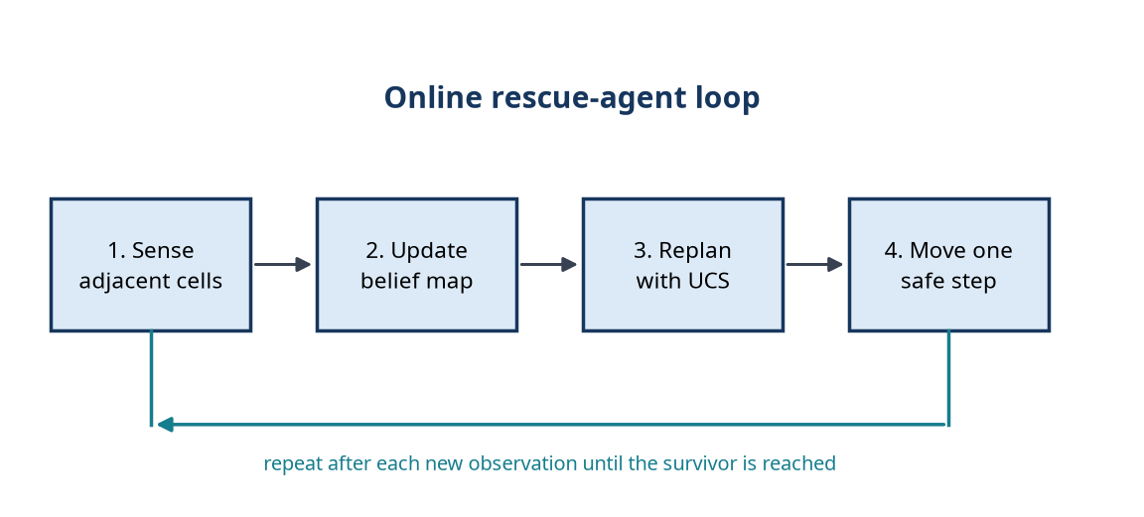
Figure 6. The robot makes one safe move at a time and updates its map after each new observation.
A practical online agent can maintain each cell as “unknown,” “free,” “blocked,” or “risky.” A conservative implementation treats unknown cells as unavailable for the current route, moves to a reachable frontier (a known free cell adjacent to unknown space), senses again, and re-runs UCS. This may require exploration before the goal becomes reachable in the known map. Once enough of the relevant map is known, UCS finds the least-cost route in that known graph.
- Observe the four adjacent cells and record whether each is free, blocked, or risky.
- Update the belief map; keep verified information unless a new observation contradicts it.
- Run UCS through known safe/free cells using move-plus-risk cost. If no route is known, select a reachable frontier.
- Execute one move only, then sense again; new information can make the old route stale.
- Stop when the survivor is reached. Otherwise, repeat the cycle.
Treating unknown cells as blocked is cautious, but it can delay the trip while the robot explores. If the robot has a reliable risk model, it could assign unknown cells an expected cost instead; the choice should be made explicit.

3.5 Pseudocode for an online rescue agent
known_map = {start: "free"}
position = start

while position != goal:
observations = sense_adjacent(position)
update(known_map, observations)

# Plan only through confirmed free cells; risk changes entry cost.
route = uniform_cost_search(
start=position,
goal=goal,
known_map=known_map,
step_cost=lambda cell: 1 + (2 if known_map[cell] == "risky" else 0)
)

if route exists:
next_cell = route[1] # execute one action only
else:
frontier = reachable_known_frontier(position, known_map)
if frontier is empty:
report("No known safe route; request help or new information")
stop
next_cell = lowest_cost_frontier_step(position, frontier, known_map)

if known_map[next_cell] == "blocked":
# Defensive guard: a blocked cell should never be selected.
continue
move_to(next_cell)
position = next_cell

AI concept | Application to this robot
Intelligent agent | The robot perceives adjacent cells, stores an internal state/map, chooses an action, and changes the environment by moving. Its architecture is sensors → belief/map → planner → actuators.
Rationality | A rational action is the best action given what the agent has perceived so far and its stated performance measure. Here the measure is reaching G while avoiding blocked cells and minimizing movement-plus-risk cost. Rationality is relative to available information, not perfect hindsight.
Environment type | Partially observable (limited sensing); sequential (a move affects later choices); deterministic in the sample map (move outcomes fixed); static or slowly changing unless disaster effects move hazards; discrete (grid cells/actions); single-agent in the simplified model; known action rules but initially unknown map.
Online search | The robot interleaves planning and acting because its map is revealed locally. New observations can revise the belief map and prompt re-planning.
Performance measure | Reach G safely; avoid blocked cells; minimize total cost; avoid needless backtracking.
report("Survivor reached")
A real rescue robot might also use a risk limit or ask for help when it cannot find a safe route. In this example, each risky entry adds 2 cost units, and unseen cells are treated as blocked until the robot has explored them.

3.6 AI concepts in the rescue scenario

3.7 Python UCS implementation for a known map
import heapq

N = 5
START, GOAL = (1, 1), (5, 5)
BLOCKED = {(2, 2), (3, 2), (4, 4)}
RISKY = {(1, 2), (1, 3)}
MOVES = [(0, 1), (1, 0), (0, -1), (-1, 0)]

def ucs(start, goal):
frontier = [(0, start)] # (total cost so far, cell)
best = {start: 0}
parent = {start: None}
while frontier:
cost, current = heapq.heappop(frontier)
if cost != best[current]: # skip an outdated queue entry
continue
if current == goal:
break
for dr, dc in MOVES:
nxt = (current[0] + dr, current[1] + dc)
inside = 1 <= nxt[0] <= N and 1 <= nxt[1] <= N
if not inside or nxt in BLOCKED:
continue
entry_cost = 1 + (2 if nxt in RISKY else 0)
new_cost = cost + entry_cost
if new_cost < best.get(nxt, float("inf")):
best[nxt] = new_cost
parent[nxt] = current
heapq.heappush(frontier, (new_cost, nxt))
if goal not in parent:
return None, float("inf")
path, node = [], goal
while node is not None:
path.append(node)
node = parent[node]
path.reverse()
return path, best[goal]
path, cost = ucs(START, GOAL)
print(path)
print("least total cost:", cost)

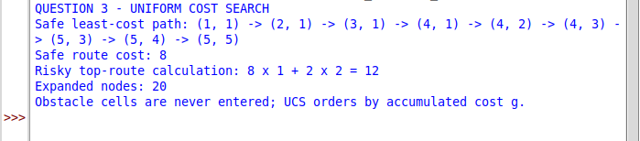
Figure 7. Direct Python IDLE 3.12.3 Shell capture after running q3_ucs.py.

